Review on Mechanical Issues and Driver Solutions of Industrial Permanent Magnet Synchronous Machine Servo Systems: Parameter Estimation and Auto-tuning Concepts
First A. Author1, Membership, Second B. Author2, Membership,
and Third C. Author3, Membership
Abstract— One of the result of the advanced industrial technology, industrial servo drive systems need advanced skills for managing the system and motion. Industrial servo systems have challenging mechanical characteristic for sensitive control and accurate stability of driver systems. These mechanical issues occur with respect to drive train of servo systems such as mechanical assembly, motion elements, motion types and loads. In this context, on the driver and control side, there are several approach and solution methods for mentioned mechanical issues. In this paper, problematic issues and offered solutions in the current literature for servo drive systems are defined and systematized.

Index Terms—Servo Drive Mechanics, Mechanical Servo Issues, Filtering in Servo, Servo Control

INTRODUCTION
A
well tuned servo system is robust and has the fastest possible response with (negligible or) no overshoot and steady state error. But, a well tuned servo system can lose its accurate response with disturbances that come from the mechanical dynamics of operated drive train. Drive train of a servo system contains controller-driver, motor and load. Controller-driver can be defined as white box, motor can be defined as grey box and load can be defined as black box. In this manner, tuning of the whole system can be done by controller-driver via motor with reflection from load to motor shaft. The main principle in tuning a servo system is detecting the unwanted situations from motor and controller side and to suppress them. For this purpose, we have to define the unwanted situations with using mathematical models and their effects on the parameters of the system for starting the tuning process. In this manner, there are two strategies for operating the tuning process as known Off-line and On-line. Off-line tuning the servo system means that defining process is done under the zero or no-load (dummy) motions []. This type tuning can be done by using some previous information (commision) or without any information (self-commision) about any part of the system. The other type On-line tuning the servo system means that defining process is done during the loaded motions. This type tuning is more complicated than Off-line tuning because it needs dynamic measurements and decision mechanism in parallel with the work done by servo system []. Both strategies are shown in flowcharts as in fig.1.
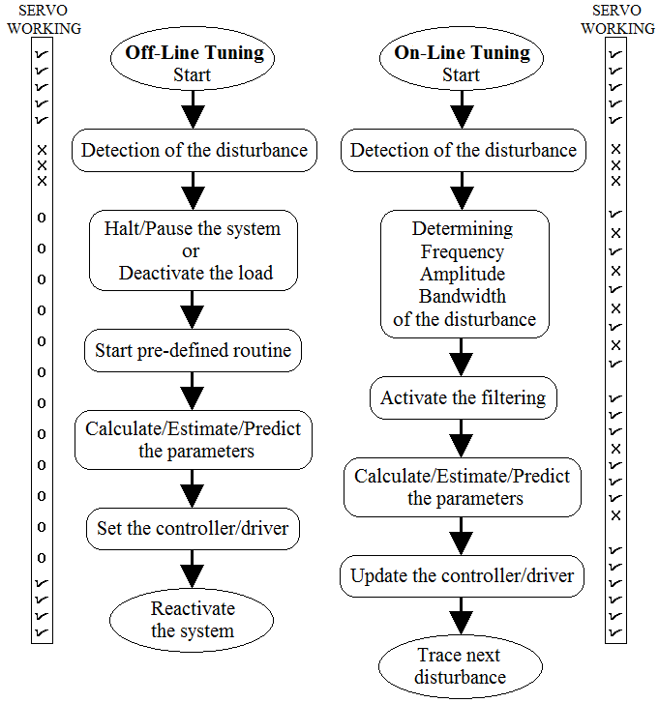
Fig. 1. Off-Line and On-Line auto-tuning flowcharts.
Possible useful methods are demonstrated for each step. Detection of the unwanted situations (disturbances) is the first step of both strategies. In real servo systems, these disturbances act as vibration, friction and mismatch []. These disturbances create detectable mechanical characteristics effects on the motor shaft that can appear as position, torque, speed, voltage or current error from controller/driver side indirectly []. Also, some of them can be detect by observation (manually or algorithmic) or using some model state variables []. After detection of the disturbance process, off-line tuning process halt or pause the system (motion is stopped) or system is unloaded (dummy motions). Then the system tries to understand the disturbances with using pre-defined routines that can be voltage/current injections, to try specific motion profiles, torque measurements, movements pushing the boundaries, specific position tracking or regular movements as same as loaded condition []. After this process system calculates or estimates the critical parameters, which are electrical, mechanical, model based or state variables, with using measured data from pre-defined routines. New parameters are integrated the controller/driver system and if need controller/driver parameters are updated with respect to new dynamics. System is reactivated []. When we look the On-line tuning process, it keeps going the regular motion (with load) with calculating the disturbance properties, which are mainly frequency, amplitude and bandwidth, as a parallel process. In this process, since the under load system is not suitable for injection signal or specific profiles, existing under load signals are used for calculation or estimation. Because of this challenge, as a parallel process, Fourier Transform based signal process, model based estimator, observer, predictor, iteration algorithms, adaptive mechanism, filtering techniques are used for determining the disturbance properties []. Also, there are some filter based (band-pass) scanning approaches for detecting the disturbance with characteristics []. After detection of disturbance properties, a filtering operation, which is mostly notch filters (in some applications low-pass and high pass topologies are used), is used for suppressing the detected disturbance during regular operation (under load) of servo systems. Some of the designers try to combine detection of the properties of the disturbance and suppression operation in same step. In this case, one of the approaches is observer/estimator strategy. In this approach an observer/estimator structure, which contains state-space equations (position, speed, voltage/current) and time dependent data collected from system, traces the system dynamics and evaluate the near future data from past data with using trajectory. Kalman Filter based estimators are commonly used for this approach []. Another commonly used approach, which is known as Model Referenced Adaptive System (MRAS) is creating and controlling/driving a model in parallel with the actual system and comparing or evaluating the data from model and actual system for tuning the system []. MRAS based other adaptive systems also derived []. Some of the systems contain Fuzzy logic, Artificial Intelligent (AI) based structures, Neural Network (NN) strategies and Swarm Intelligence (SI) based self-organized systems but they need much more computing capability and have implementation hardness [].

Mechanical issues
Most of the servo systems have a specific mechanical architecture and load properties as known drive train. A servo drive train can be characterized three different motion profiles as linear motion, circular motion and contour motion. Providing these motion, there are several mechanical auxiliaries such as, pulley-belt, lead-screw, rack-pinion, belt-wheel, conveyor and gear-wheel structures (fig.2).
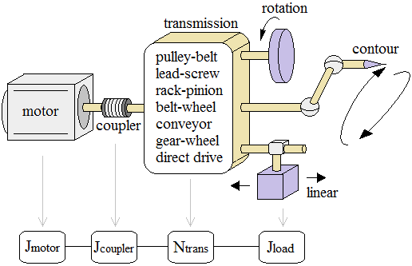

Fig. 2. Industrial servo system drive train.

These structure contains some mechanical parts are listed as rolling mill, long shafts, large inertia, bearings, elastic couplings, rail, damping elements, belt, gears etc. return vibration (resonance or randomly), friction or sliding on the transmission and then these effects are seen by motor side as reflected inertia, viscous friction and torque (from controller/driver side as position, speed, voltage/current error).

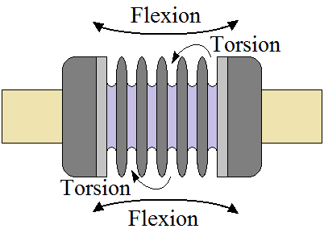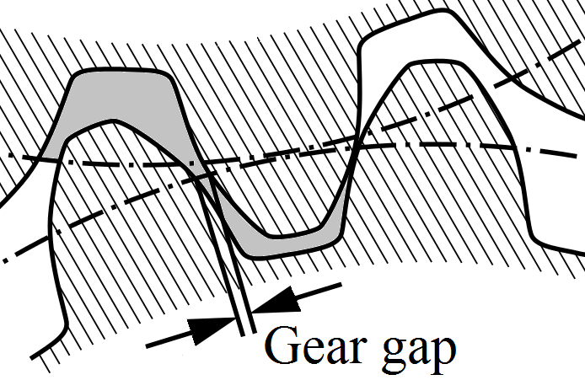
(a) (b)

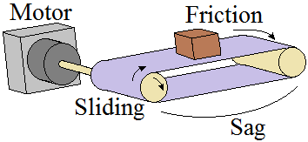
(c)
Fig. 3. Vibration and friction sources in servo drive train. (a) Elastic coupling, (b) Gear transmissions, (c) Conveyor transmission.

These type mechanical issues must be compensated as possible as by controller/driver structure with using a detection-filtering method. For this purpose electrical and mechanical parameters of the system and auxiliary variables, which are used for modeling or defining the reflections must be defined in controller side as shown in Table 1.

TABLE I
Servo System Main Parameters and Variables
Variables | Electrical Parameters | Mechanical Parameters
$P$: Pole number | $r_{s}$ : Series resistance | $T_{e}$ : Electromech. torque
$w_{r}$: Speed elect. | $L_{d}$ : d-axis inductance | $T_{L}$ : Load torque
$w_{m}$: Speed mech. | $L_{q}$ : q-axis inductance | $K_{t}$ : Torque constant
$s$: Laplace operator | $K_{e}$ : Back EMF const. | $J$ : Rotor and load inertia
$v_{do},v_{qo}$:Back EMF, Cross coupling volt. | $λ_{m}$ : PM flux linkage | $B$: Viscous friction coeff.

Modeling

Motor Model
Modeling of the servo drive train have critical role in tuning operation because the real system behavior have to run in the controller side. Modeling can be categorized in three main parts as mechanical model, machine model, controller/driver model. For this purpose, PMSM machine (there are two types as SPMSM and IPMSM) mathematical model with respect to stationary rotating d-q frame is given in fig.4 and as follows.

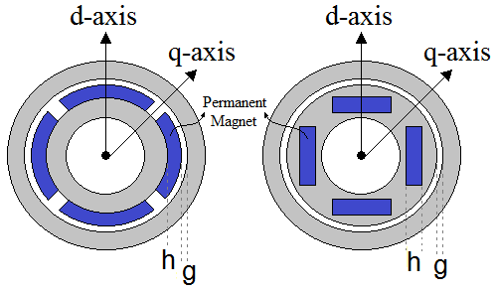
Fig. 4. SPMSM and IPMSM structure and d-q frame axes.

For SPMSM: $L_{d}=L_{q}=\frac{µ_{0}N^{2}A}{2(g+h)}$ | (1)
For IPMSM: $L_{d}=\frac{µ_{0}N^{2}A}{2(g+h)} , L_{q}=\frac{µ_{0}N^{2}A}{2(g)}$ | (2)

d-q axis voltage/current $(v_{d},i_{d},v_{q},i_{q})$, speed and torque expressions with respect to rotating d-q frame are given below.

$$\frac{di_{q}}{dt}=\frac{1}{L_{q}}(v_{q}-r_{s}i_{q}-λ_{m}w_{r}-L_{d}w_{r}i_{d})$$ | (3)
$$\frac{di_{d}}{dt}=\frac{1}{L_{d}}(v_{d}-r_{s}i_{d}+L_{q}w_{r}i_{q})$$ | (4)
$$\frac{dw_{r}}{dt}=\frac{P}{2J}(T_{e}-\frac{2B}{P}w_{r}-T_{L})$$ | (5)
$$T_{e}=\frac{3}{2}\frac{P}{2}(λ_{m}i_{q}+\left(L_{d}-L_{q}\right)i_{d}i_{q})$$ | (6)

Equations (3-6) represent a PMSM machine mathematical model and variables in these equations are referred by Table 1.

Mechanical Model
Experimental mechanical implementation of the servo systems are created by using two ways as using flywheels [] or two or three mechanically coupled motors system (one of them represent motor, other one acts as load). In general, they are called two-mass (motor-load) or multi-mass (motor - coupling1 - load1 - coupling2 - load2 – coupling n - load n) systems [] as shown in fig 5.
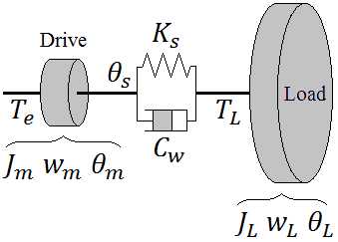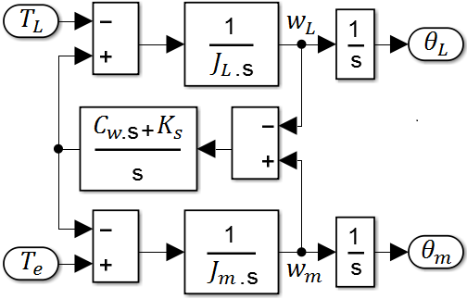
(a) (b)

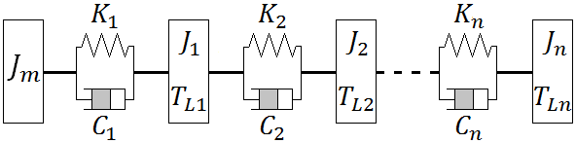
(c)

Fig. 5. Mechanical model, (a) two-mass system physical model (b) two-mass system mathematical block model (c) multi-mass model
In two mass model approach, there are two side that are connected with a coupling or any connector. Each sides (driver and load) have dependent torque ($T$), inertia ($J$), speed ($w$) and position ($θ$). The dependence is comes from coupling that has two critical parameters as stiffness ($K_{s}$) and damping ($C_{w}$).

Controller/Driver Model
In controller side, most of the servo drive systems use Field Oriented Control (FOC) in rotating d-q frame. Position, speed and current/voltage control loops are located sequentially and they are controlled by PID []. Some specific applications (torque dominant) use Direct Torque Control (DTC) technique if there is no need any sensitive speed or position control need []. Another control action for these systems is Model based control systems. These type controller works with a mathematical model of a plant (only motor or motor with load) and a predictor, estimator or adaptive structure []. In driver side, three phase inverter with sine PWM or Space Vector PWM techniques are commonly used. Also, specific vector tables for DTC or look-up tables for model based control systems are used.
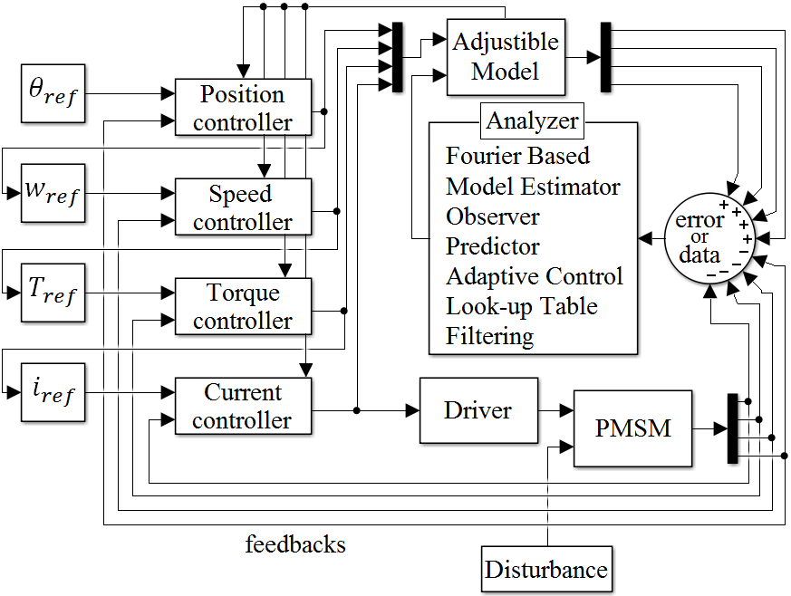
Fig. 6. Generic controller/driver approach for auto-tuning and parameter estimation in servo systems.

Disturbance Detection Methods
The main idea of auto-tuning process is detecting the disturbance signal from feedbacks or measured data of the servo system. An unknown electrical signal has three main characteristic such as frequency, amplitude and bandwidth (or duration of disturbance). Also another critical data about disturbance is formation, which can be periodic or non-periodic. In addition, non-periodic formations can be categorized as follows, pure random, limited random, changing in certain order or dependent to any system’s variable (electrical or mechanical).

Fourier Transform Based
In Fourier transformation based techniques, detection system contains two main parts as signal analyzer in frequency domain and filter. This technique needs excessive computing ability (high process DSP). The work flow of this technique contains three basic processes. The first one is collecting the position, speed, current/voltage or torque error data (whichever system is controlled) and these data is saved in a memory element. After that Fourier analysis of collected data is done. At this step classical FFT or DFT computation takes much more time in real time systems. Overcome this challenge, designers determine a resolution for FFT computing according to overall servo system needs. For this purpose, shifted DFT (SDFT) (DFT computing is done when the frequency window is shifted with fixed length) or DWT techniques are in use. The main logic is decrease the computing time with decreasing the detection frequency resolution of system (2048 point data with Advantech 610H industrial control computer takes 3ms for traditional DFT, 0.1ms for SDFT) [jian kang online detection and suppression]. The second step is, collected and transformed data are sorted (or grouped) with respect to amplitude or center frequency. In this stage, it is known that motor and load controller variables (position speed, current/voltage, torque) are oscillating at resonance frequency. So, in sorted data, the most dominant frequency (or the biggest amplitude) refers to resonance frequency of the system and other ones are vibrations or frictions sourced. The last step is filtering the significant frequencies with side lobes. The coefficients of filter (According to specifications, system has one or more than one filter action such as notch with multi channel, low-pass, high-pass, band-pass) are set. After activating the filtering, disturbance of the system eliminated and controller reference signals are purified. Fig. 7 shows that generic block diagram and FFT analyzer with DSP block (encircled) where detection steps run. Also, a filter block is complement of the detection system.

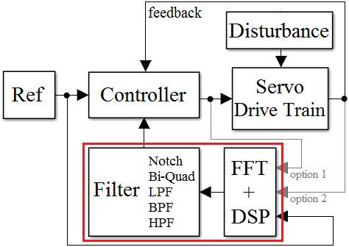

Fig. 7. FFT based disturbance detection system generic block diagram.

Model Based Estimator/Observer/Predictor
Pack everyth

Adaptive Control Systems

Others

Filters
A general IEEE style guide is available at

System Management
If you are

Conclusion

Conclusion
A conclusion section is not required. Although a conclusion may review the main points of the paper, do not replicate the abstract as the conclusion. A conclusion might elaborate on the importance of the work or suggest applications and extensions.

References
- F. N. Author1 and F. N. Author2, “The title of the conference,” in Title of the Proceeding, vol. 3, DOI XX/XXXX/ZZZ.XXXX.XXXXXXX, pp. 1–6, Apr. 2003.
- F. N. Author1, F. N. Author2 and F. N. Author3, “The title of the article,” Other Journal, vol. IA-21, DOI XX/XXXX/ZZZ.XXXX.XXXXXXX, no. 4, pp. 814–821, Mar. 1990.
- F. N. Author1, “The title of the article,” Journal title, vol. 56, DOI XX/XXXX/ZZZ.XXXX.XXXXXXX, no. 2, pp. 581–588, Feb. 2009.
- F. N. Author1, F. N. Author2 and F. N. Author3, “The title of the patent,” Jounal Name, no. 146643245, Oct. 1990.
- F. N. Author, The title of the online book, ser. Example Series. P. Name, Apr. 2003. [Online]. Available: http:// books.google.es
- F. N. Author, Title of the book, 3rd ed., ser. series 1. The address of the publisher: The name of the publisher, vol. 4, ch. 8, pp. 201–213, Apr. 1993, an optional note.

First A. Author1 and the other authors may include biographies at the end of regular papers. The first paragraph may contain a place and/or date of birth (list place, then date). Next, the author’s educational background is listed. The degrees should be listed with type of degree in what field, which institution, city, state or country, and year degree was earned. The author’s major field of study should be lower-cased.
The second paragraph uses the pronoun of the person (he or she) and not the author’s last name. It lists military and work experience, including summer and fellowship jobs. Job titles are capitalized. The current job must have a location; previous positions may be listed without one. Information concerning previous publications may be included.
The third paragraph begins with the author’s title and last name (e.g., Dr. Smith, Prof. Jones, Mr. Kajor, Ms. Hunter). List any memberships in professional societies other than the IEEE. Finally, list any awards and work for IEEE committees and publications. If a photograph is provided, the biography will be indented around it. The photograph is placed at the top left of the biography. Personal hobbies will be deleted from the biography.

Second B. Author2 (M’12) was born in City, Country. He received the M. degree in electrical engineering from University of City, Country in 2012.
The second paragraph uses the pronoun of the person (he or she) and not the author’s last name. It lists military and work experience, including similar information to the previous author, including military, work experience, and other jobs. Job titles are capitalized. The current job must have a location; previous positions may be listed without one. Information concerning previous publications may be included.
The third paragraph begins with the author’s title and last name (e.g., Dr. Smith, Prof. Jones, Mr. Kajor, Ms. Hunter), including similar information to the previous author, including the list of any awards and work for IEEE committees and publications. The photograph is placed at the top left of the biography. Personal hobbies will be deleted from the biography.

Third C. Author3 (M’99–SM’04–F’09) was born in City, Country. He received the M. and SM. and F. degrees in electrical engineering from University of City, Country in 1999, 2004 and 2009 respectively.
The second paragraph uses the pronoun of the person (he or she) and not the author’s last name. It lists military and work experience, including similar information to the previous author, including military, work experience, and other jobs.
The third paragraph begins with the author’s title and last name (e.g., Dr. Smith, Prof. Jones, Mr. Kajor, Ms. Hunter), including similar information to the previous author, including the list of any awards and work for IEEE committees and publications. The photograph is placed at the top left of the biography. Personal hobbies will be deleted from the biography.

Manuscript received Month xx, 2xxx; revised Month xx, xxxx; accepted Month x, xxxx. This work was supported in part by the … Department of xxx under Grant (sponsor and financial support acknowledgment goes here). (Authors’ names and affiliation) F. A. Author1 and S. B. Author2 are with the xxx Department, University of xxx, City, State C.P. Country, on leave from the National Institute for xxx, City, Country (e-mail: author@domain.com). T. C. Author3 is with the National Institute of xxx, City, State C.P. Country (corresponding author to provide phone: xxx-xxx-xxxx; fax: xxx-xxx-xxxx; e-mail: author@ domain.gov).

